# **OPERATING SYSTEM**

# **EXPERIMENT 11**

# **SHARED MEMORY AND MESSAGE QUEUE**

# **Submitted by: -**

# **Ayushi Kumari**

# **RA1911003010865**

**1.**

**Aim: INTER PROCESS COMMUNICATION –Shared memory**

**Objective:** The program to implement inter process communication using shared memory and message queue concept. Program:1. Shared memory implementation using readers writer’s problem.

**Code-**

**Writer’s code:**

#include <sys/ipc.h>

#include <sys/shm.h> #include <stdio.h>

int main()

{

key_t key = ftok("shmfile",65);

int shmid = shmget(key,1024,0666|IPC_CREAT);

char *str = (char*) shmat(shmid,(void*)0,0);

printf("Write Data : ");

gets(str);

printf("Data written in memory: %s\n",str);

shmdt(str);

return 0;}

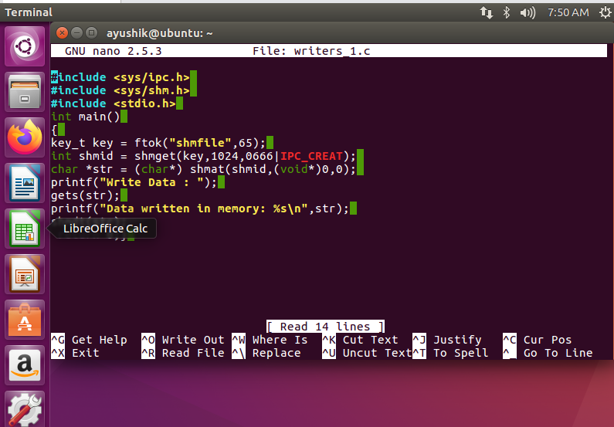

**Reader’s Code:**

#include <sys/ipc.h>

#include <sys/shm.h> #include <stdio.h> int main()

{

key_t key = ftok("shmfile",65);

int shmid = shmget(key,1024,0666|IPC_CREAT);

char *str = (char*) shmat(shmid,(void*)0,0);

printf("Data read from memory: %s\n",str);

shmdt(str);

shmctl(shmid,IPC_RMID,NULL);

return 0;}

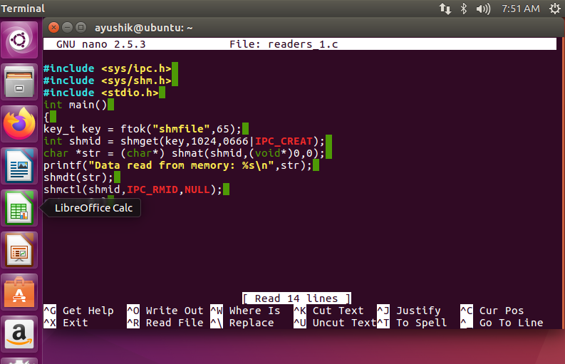

**Output-**

Write Data: Ayushi Kumari

Data written in memory: Ayushi Kumari

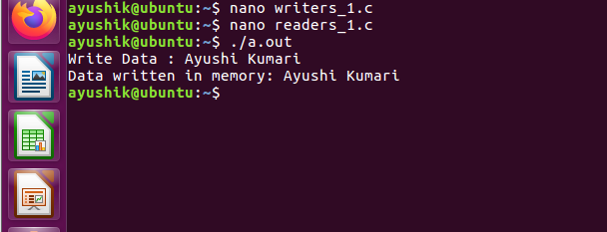

**2.AIM: INTER PROCESS COMMUNICATION –Message Queue**

**Objective:** The program to implement Inter process communication using message queue concept.

Code-

**Writers Code:**

#include <stdio.h>

#include <sys/ipc.h>

#include <sys/msg.h> #define MAX 10 struct mesg_buffer { long mesg_type;

char mesg_text[100]; } message;

int main()

{

key_t key;

int msgid;

key = ftok("progfile", 65);

msgid = msgget(key, 0666 | IPC_CREAT); message.mesg_type = 1;

printf("Write Data : "); fgets(message.mesg_text,MAX,stdin);

msgsnd(msgid, &message, sizeof(message), 0); printf("Data send is : %s \n", message.mesg_text);

return 0;

} 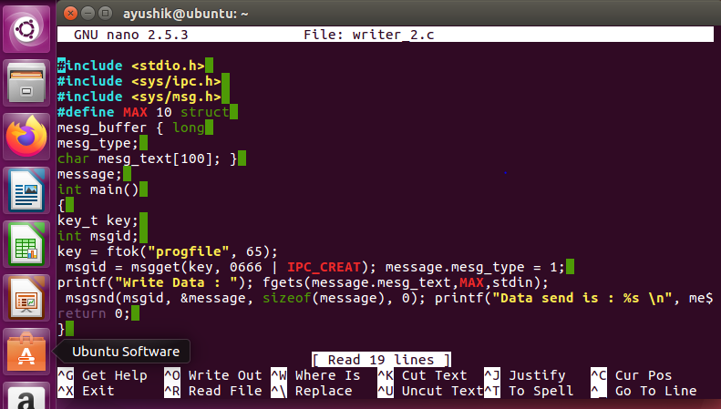

**Reader Code:**

#include <stdio.h>

#include <sys/ipc.h> #include <sys/msg.h>

struct mesg_buffer {

long mesg_type;

char mesg_text[100];

} message; int main()

{

key_t key;

int msgid;

key = ftok("progfile", 65);

msgid = msgget(key, 0666 | IPC_CREAT); msgrcv(msgid, &message, sizeof(message), 1, 0);

printf("Data Received is : %s \n", message.mesg_text); msgctl(msgid, IPC_RMID, NULL);

return 0;}

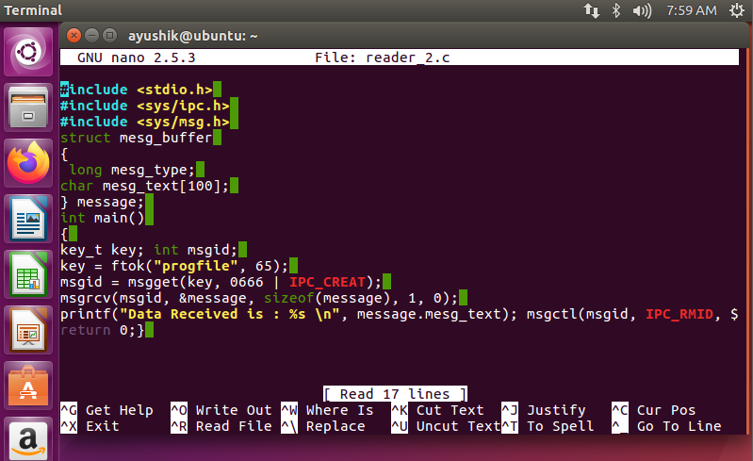

**Output: -**

Write Data: Ayushiii

Data written in memory: Ayushiii



**Result:**

* Inter process communication using shared memory concept learned and implemented.
* Thus, the concept of Inter process Communication using message Queue has been implemented using readers writer’s problem.